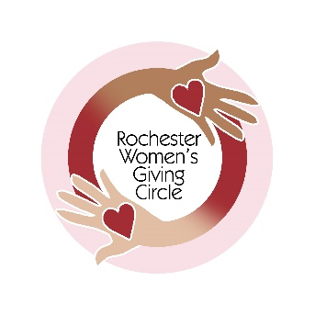 |  | The Rochester Women’s Giving Circle  Supporting women and girls on their journey  to economic independence

Name

Address

City, State Zip

Phone

Email

There are two options for membership financial contribution:
Sustainer is an Annual contribution of $1050* or more. Catalyst is an Annual contribution of $450* -$1049*.
The monies collected in each calendar year become the amount available for Grants the following spring. Our collective giving is dependent on annual membership financial contributions and any other monetary gifts the RWGC receives. $50 of each contribution supports our operating expenses. The entire amount is tax-deductible.
There are two ways to send your membership contribution.
By check, make your check payable to Rochester Area Community Foundation. Please write ”RWGC” on the memo line. If you are a new member, please write “new member” on the memo line as well.
Mail check to: Please mail this form (and your check, if enclosed) to:
Rochester Area Community Foundation
500 East Avenue
Rochester, NY 14607
By credit card, you can make a secure credit card donation through the Rochester Area Community Foundation’s website
at www.racf.org/donors/give-now/donate-online/
Be sure to select Rochester Women’s Giving Circle as the fund to receive the gift.
*An additional $30 is needed if paying by credit card to cover the credit card processing fees.
Information for the Community Foundation:
☐ Check here if you prefer not to be listed in the Community Foundation’s Donor Listing.
☐ Check here if you prefer not to receive the Community Foundation’s mailings.

